

# CLOUD COMPUTING LAB

**BSE ( V-B )**

Submitted By:

Musfira Farooq

Roll No:

2023-BSE-045

Submitted To:

Sir Muhammad Shoaib

**LAB 04**

# Virtualization & Linux Fundamentals

## **Task 1**

Shows VM’s CPU, RAM, disk size, and network adapter details.

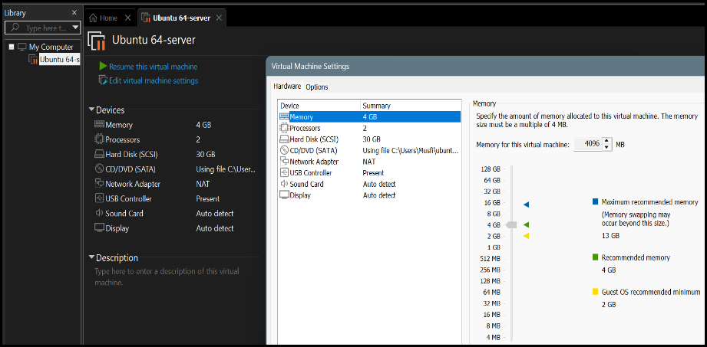

## **Task 2**

SSH connection from host terminal to Ubuntu VM.

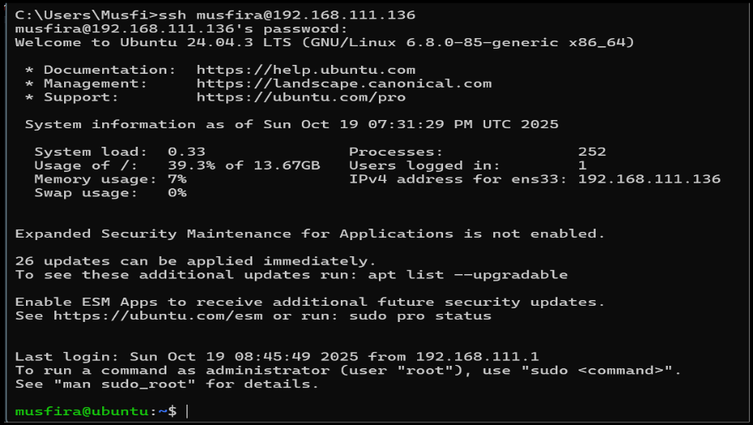

Output of whoami and pwd commands confirming user and directory.

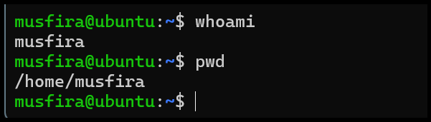

## **Task 3**

1. Contents of root / directory.

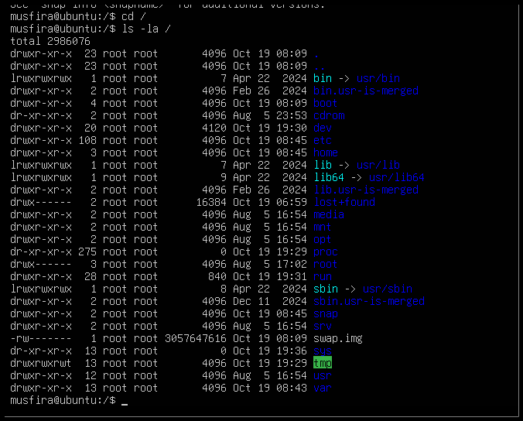

1. Executable binaries in /bin.



1. System binaries in /sbin.



1. Subdirectories and programs in /usr.

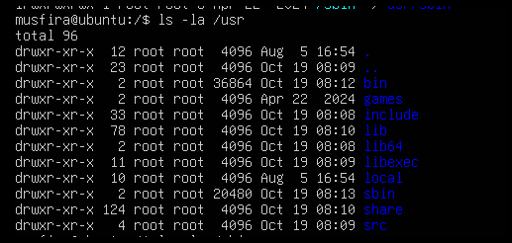

1. Optional software folder /opt.

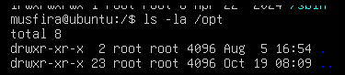

1. Configuration files directory /etc.

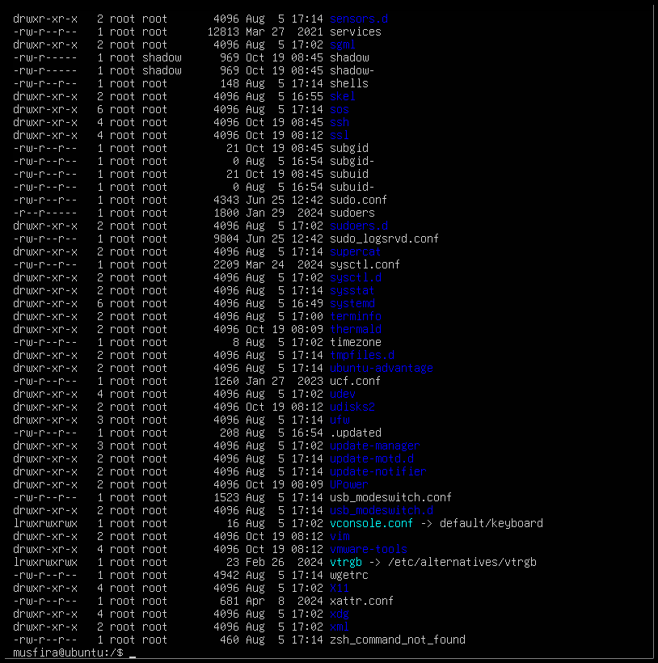

1. Device files directory /dev.

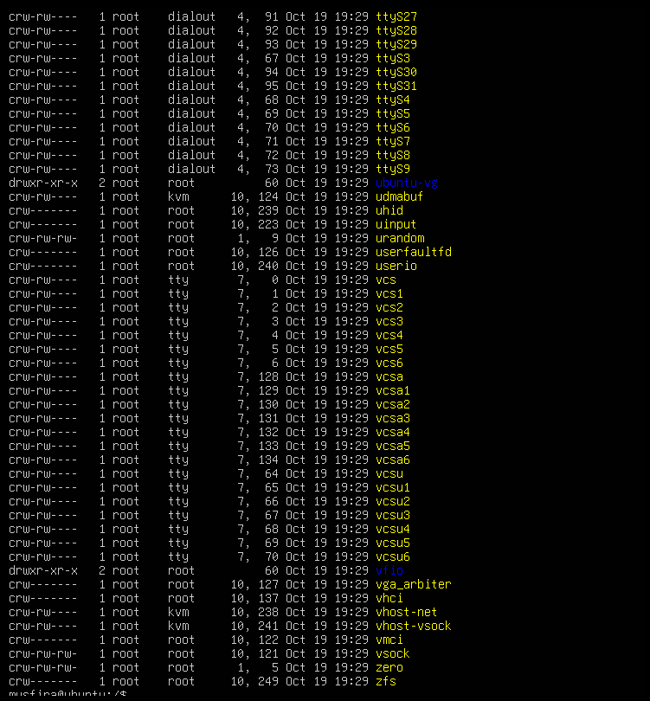

1. Variable files like logs in /var.

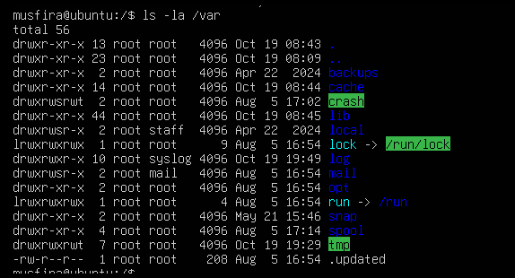

1. Temporary files directory /tmp.

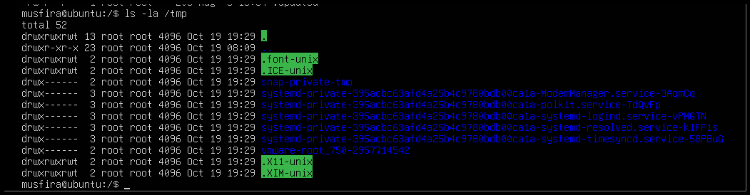

1. Contents and hidden (dot) files in home directory.

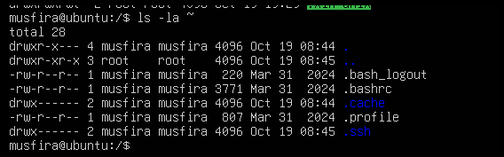

1. Explanation of /bin, /usr/bin, and /usr/local/bin written in nano editor.

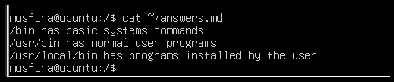

### **Task 4**

1. Created and saved README.md file.

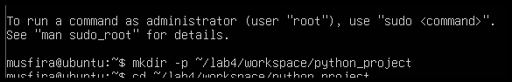

1. Created and saved main.py with print statement.



1. Created .env file with environment variable.



1. Listed all files (including hidden).

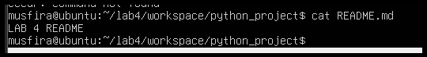

1. Copied README.md to README.copy.md.

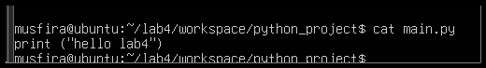

1. Renamed copied file to README.dev.md.

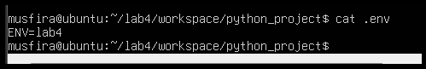

1. Deleted the renamed file.

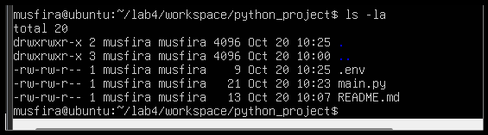

1. Created new folder java_app.



1. Copied entire folder recursively.

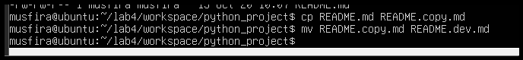

1. Verified copied folders in workspace.



1. Displayed recent command history.



1. Demonstrated Linux tab auto-completion.



1. Verifying copy.

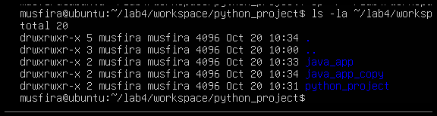

1. History.

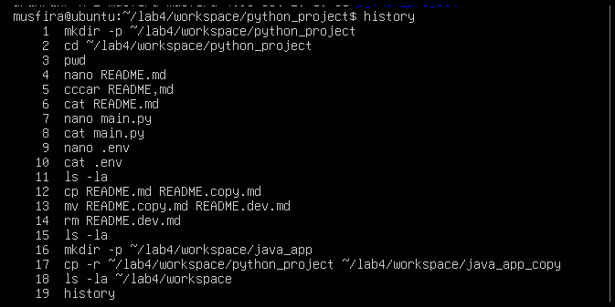

1. Tab completion.



### **Task 5**

1. Shows kernel and OS information.



1. CPU details with model name.

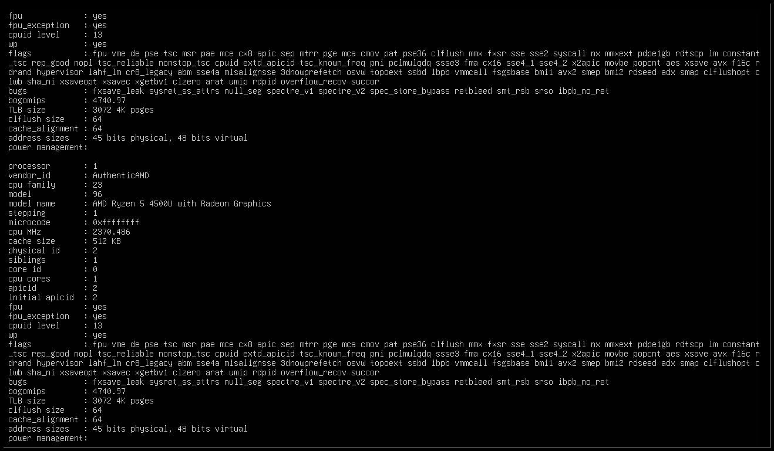

1. Memory statistics using free -h.

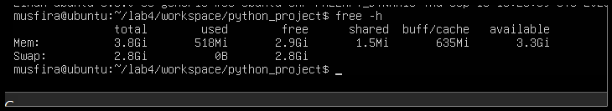

1. Disk space usage using df -h.

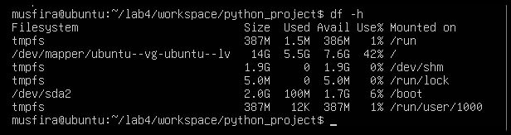

1. Ubuntu version information.

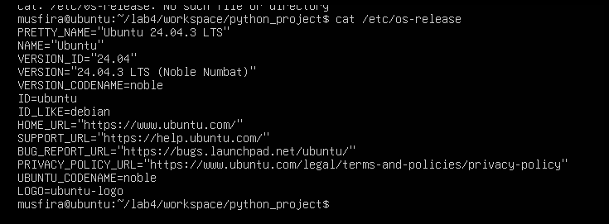

1. List of active processes using ps aux.

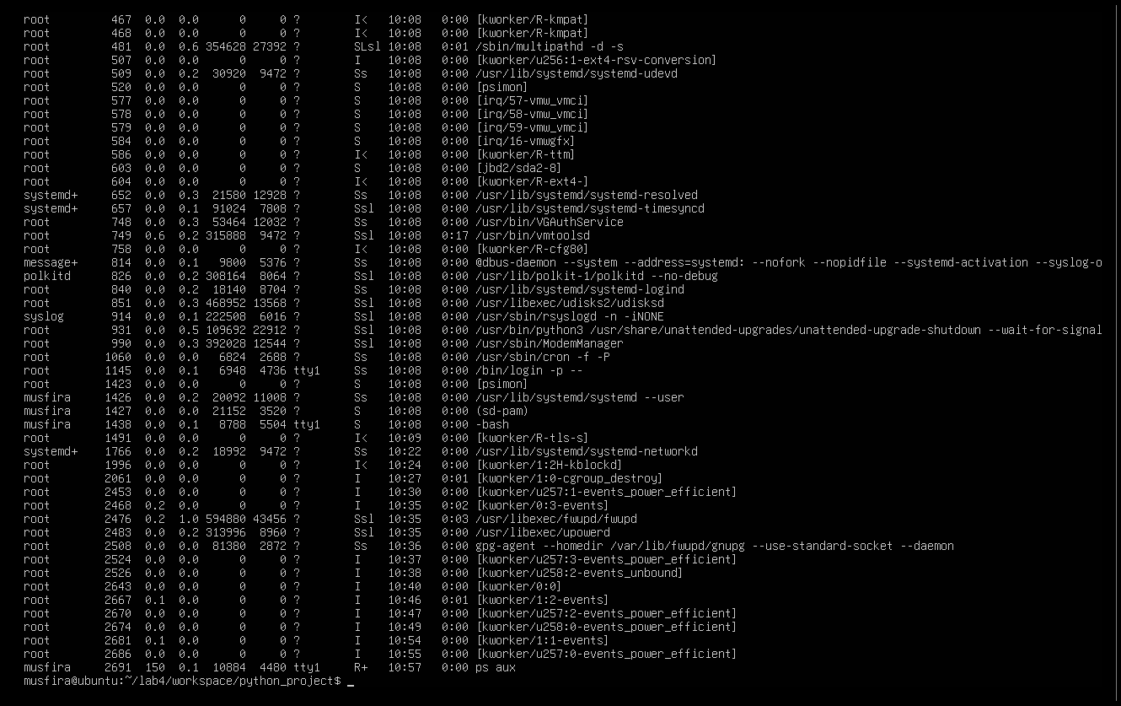

### **Task 6**

1. User lab4user created successfully.

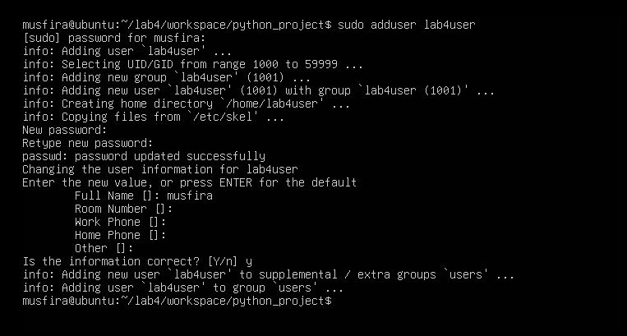

1. Verified user entry in system database.



1. Logged in as lab4user.

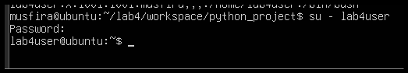

1. Attempt to use sudo (expected failure).

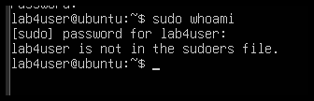

1. Returned to main account.

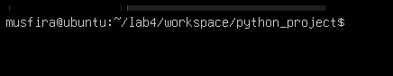

1. (Optional) Deleted the test user.

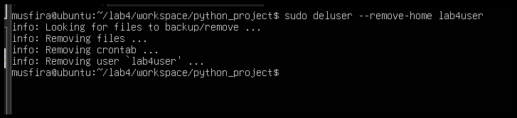

**Bonus Task 7**

1. Script content in nano editor.

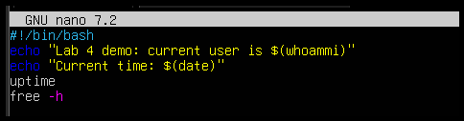

1. Script made executable.



1. Script executed successfully.

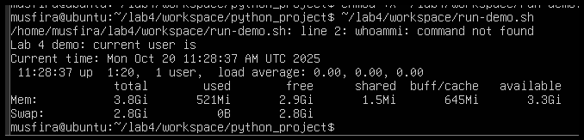

1. (Optional) Script run with sudo privileges.

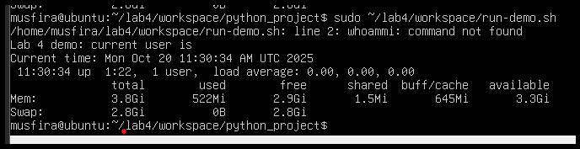

### **Exam Evaluation Questions**

**Q1 – Remote Access Verification**

1. Remote SSH connection established.

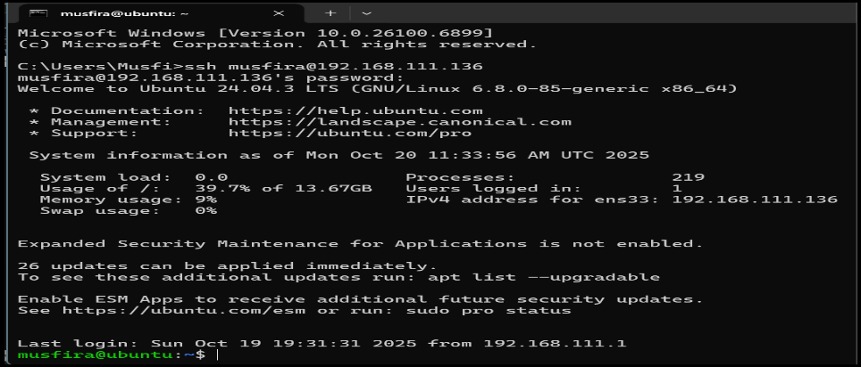

1. Verified user and home directory.

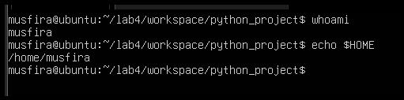

1. Confirmed correct host system.

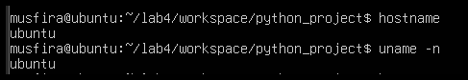

### **Q2 – Filesystem Inspection for Forensic Evidence**

1. Root directory listing.

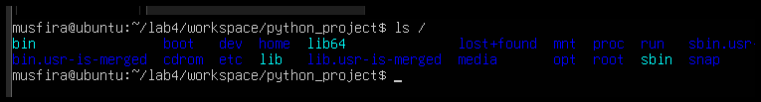

1. OS version and release info.

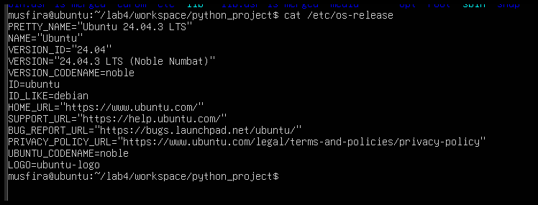

1. Listings for /bin, /sbin, /usr, /opt, /etc, /dev, /var, /tmp.

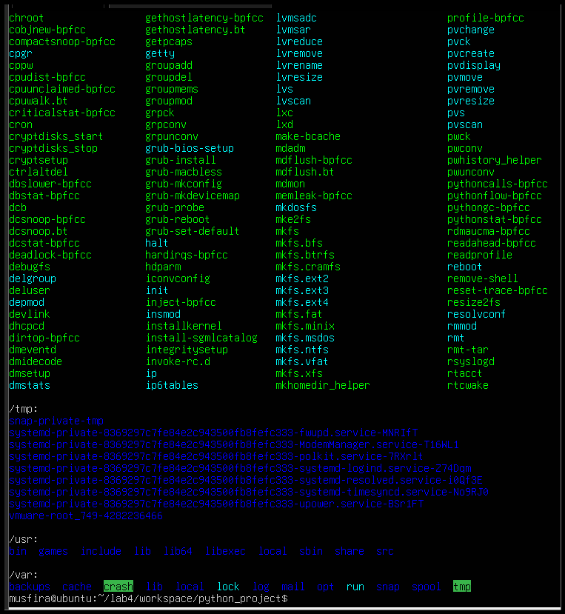

1. Hidden files in home directory.

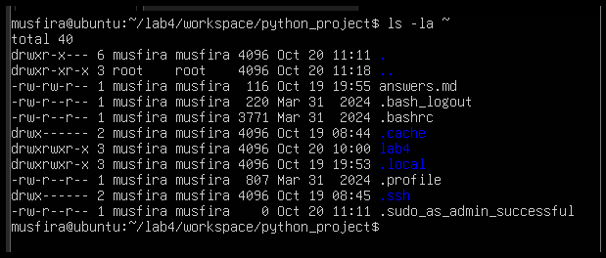

1. Markdown summary of findings.

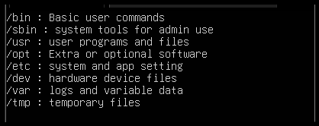

### **Q3 – Evidence Handling & File Operations**

1. Created structured workspace.

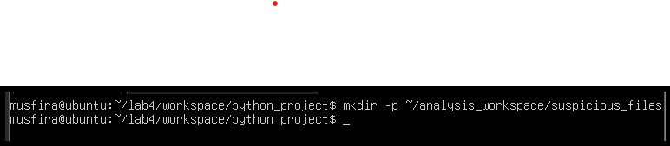

1. Three text files created (one hidden).

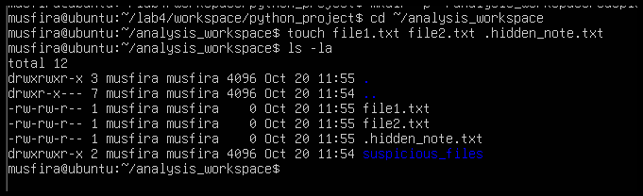

1. Backup copy, rename, and delete demonstrated.

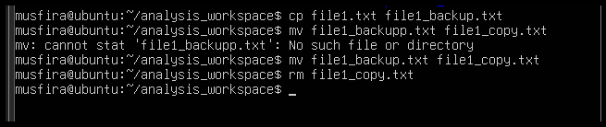

1. Copied workspace as backup folder.

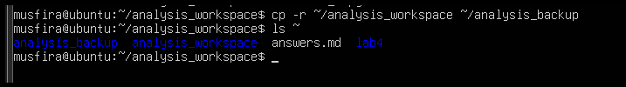

1. Displayed command history for documentation.

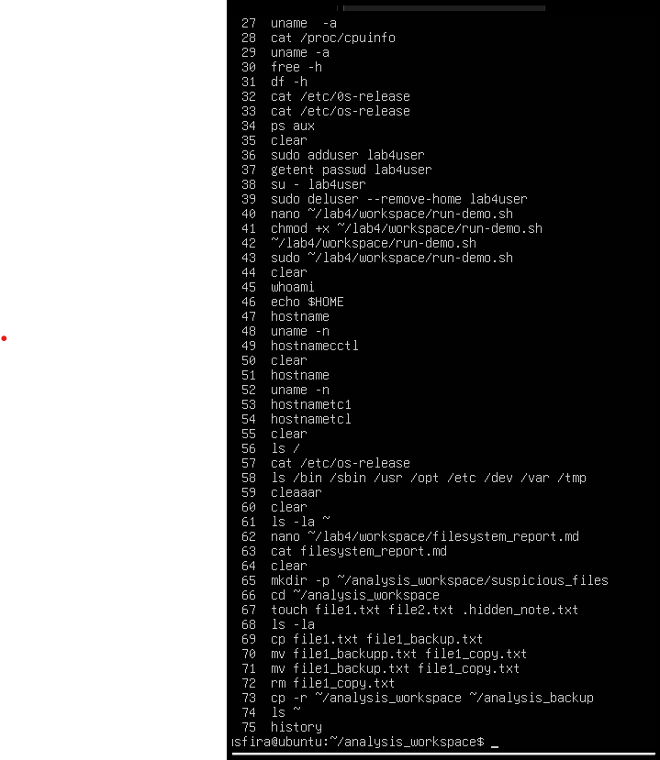

1. Shown tab auto-completion example.

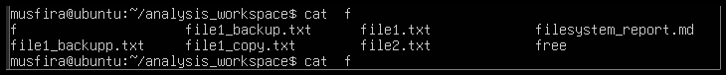

### **Q4 – System Profiling & Process Monitoring**

1. Kernel and OS version.



1. CPU, memory, and disk stats.

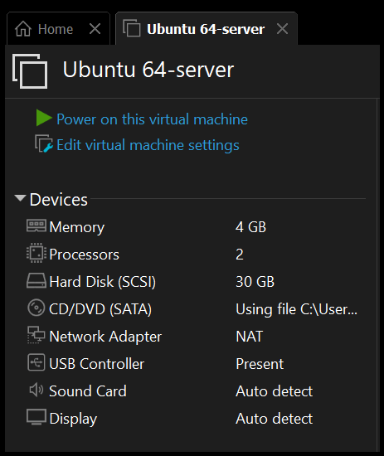

1. Running processes list.

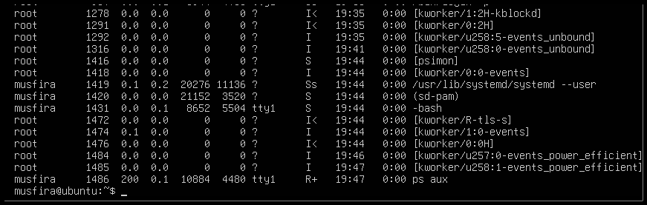

### **Q5 – User Account Audit & Privilege Escalation Simulation**

1. New user lab4user added.

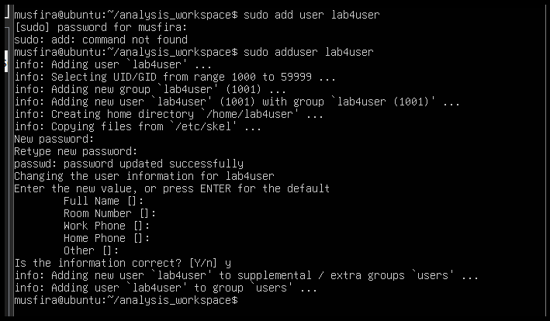

1. Verified user record in system.

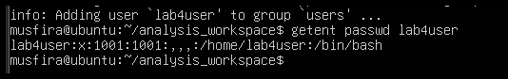

1. Logged in as lab4user.

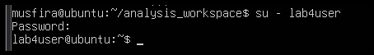

1. Attempted sudo command (denied).

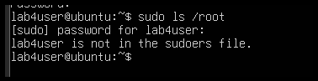

1. Returned to main analyst account.

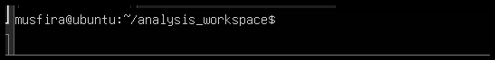

1. Checked authentication logs for login attempts.

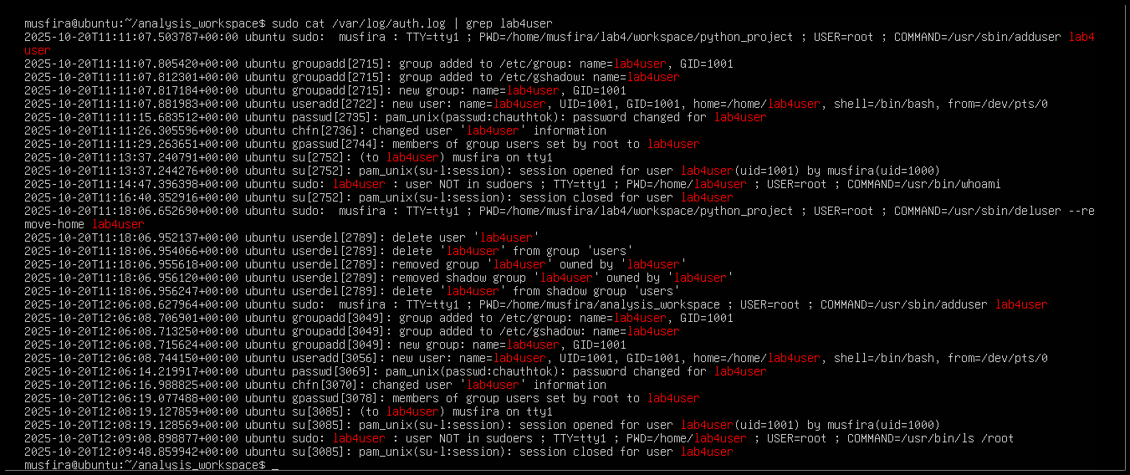

1. (Optional) Deleted test user after audit.

